# Task 2.1

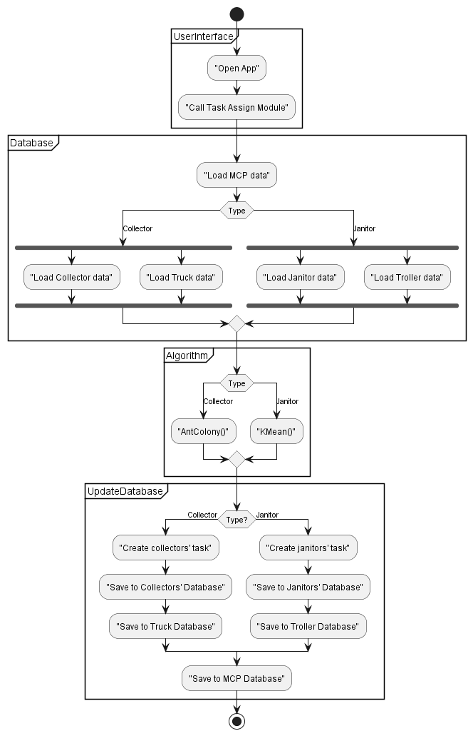

# Task 2.2

Route planning module includes the following steps:

* Retrieve information about MCPs (location, traveling distance to other MCPs…)
* Retrieve information about collectors and janitors (work days, location…)
* Retrieve information about vehicles (capacity…)
* From information about MCPs, employees, and vehicles, apply algorithm to automatically plan approriate routes and schedule for everyone.
* Message janitors and collectors about their new routes and schedule.

Sequence diagram:

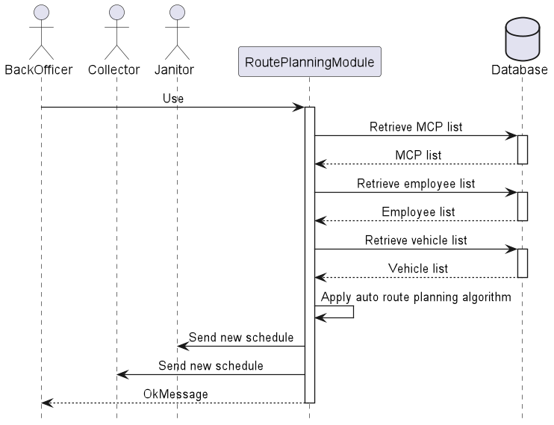

# Task 2.3

